MarvellousMe on your school website

Why add a MarvellousMe page to your school website?
- Promote MarvellousMe to your parents and help them to get started quickly.
- Show prospective parents how good you are at keeping them informed about the wonderful things that their children are learning and achieving at school.
- Impress inspectors when they review your parental communications strategy.

What might you be able to do on your website, to promote MarvellousMe?
- Add a link somewhere prominent, maybe on your homepage. Some sites will allow you to create quick links, and banners, or you may be able to add the logos from awarding bodies and affiliated organisations, somewhere like your website footer.
- Add a page to your website, with information for parents about how to access MarvellousMe, and how it will benefit their child(ren).
- If you have a news area or blog on your website, you might want to create a story or post about the launch.
- If you share newsletters via your site, don’t forget to include information in each issue, to keep families engaged, and to encourage new parents to access MarvellousMe.

What resources do you have available to help me?
You can use our Logos:

And images of the MarvellousMe app:
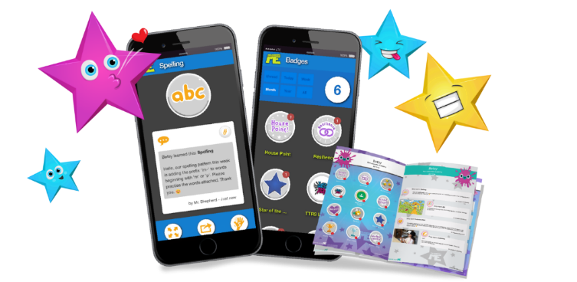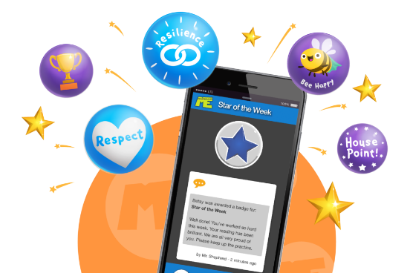.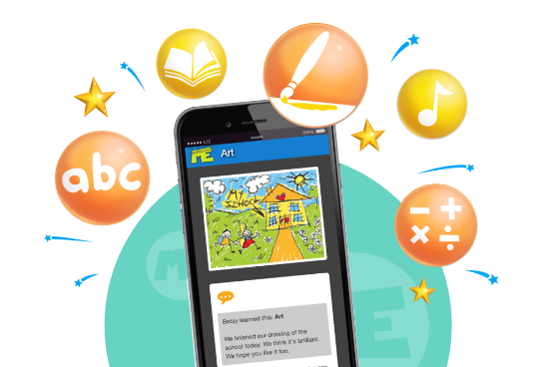

Plus, here is some suggested text that you may wish to use on your webpage, and in other communications:
Get wonderful news about your child’s learning and success.
MarvellousMe is an exciting app that tells you about the wonderful things that your child is learning and pings you when they’ve been praised for good work or a great character skill.
It makes you smile, feel proud, and inspires better home learning support and encouragement.
Get Started. It’s free!
- Download the MarvellousMe parent app, or join up at www.marvellousme.com
- Tap ‘Sign Up’
- Enter the join code provided by your child’s teacher.
- Enter your name and email address, then make up a password.

Top Tips
- Invite partners, grandparents and carers to join up too.
- Tap ‘Settings’ and then choose ‘Share your app.’
- Send a Hi5 back every time you get wonderful news.
- Add more children by tapping ‘Add child’. Then enter their name and join code.
- Access useful information by tapping the links under the child’s avatar.
- Get help at www.marvellousme.com.

Other ideas for your text:
- Add a comment from the Headteacher.
- Share positive MarvellousMe stories about numbers of parents joining, badges awarded etc. as these become available.
- Include a MarvellousMe Case Study. Please speak with us, if you would like one.

Hyperlinks and App/Google Play Store icons
Add the relevant hyperlinks to www.marvellousme.com, where appropriate.

Add this link to the Apple App Store icon. It takes parents directly to the MarvellousMe Parent app: https://itunes.apple.com/gb/artist/cloudthing/id931841061

Add this link to the Google Play Store icon. It takes parents directly to the MarvellousMe Parent app: https://play.google.com/store/apps/developer?id=CloudThing+applications

